Client Counsellor Contract
This contract acts as an agreement as to how we will work together and outlines my professional obligations, such as upholding confidentiality. We will discuss the contract at the beginning of our first session, where you will be able to raise any questions or concerns.
I abide by the BACP Ethical Framework to ensure I’m working safely and putting my clients first. The Ethical Framework can be found at - https://www.bacp.co.uk/media/3103/bacp-ethical-framework-for-the-counselling-professions- 2018.pdf
Initial Assessment
I offer a free 20-30 minute phone or video call prior to commencement of sessions to carry out an initial assessment and discuss the client’s reasons for seeking counselling. It is also vital to see how we get along, which I feel is crucial to the work, for both client and counsellor.
Sessions
Sessions will take place weekly lasting for 50 minutes, set at an agreed date and time. The number of sessions will be by agreement between the client and counsellor. The sessions and the objective of the counselling will be reviewed between the client and the counsellor regularly, to ensure the client is benefitting from their time in counselling. It is vital to the process that a commitment is made and sessions are attended regularly, to create consistency and develop the therapeutic relationship. Sessions will start and end at the agreed time so punctuality is important.
Fee
The agreed upon fee is required by bacs prior to the session to give both client and counsellor peace of mind. However, in face-to-face sessions, a client may pay at the beginning of the session with cash by arrangement. Clients can pay on a week-to-week basis or may book and pay for a block of sessions.
Cancellations & Holidays
It is important that both client and counsellor give at least a weeks before a planned holiday, to ensure ruptures are avoided and that breaks can be worked towards.
With the exception of extenuating circumstances such as ill health and emergency situations, late cancellations or DNAs will need to be paid for where an alternative appointment cannot be arranged.
If more than 2 consecutive sessions are missed, counselling will be brought to a close - unless there are extenuating circumstances, or the missed sessions are prearranged.
Bank details
Helen Skene
Sort code:
Account number:

Confidentiality
Confidentiality plays a vital role in counselling, and is something that I take very seriously, to ensure that my clients feel safe and respected. Confidentiality applies to the records I keep and the information a client discloses in a session, with the following exceptions:
- As a professional counsellor, it is an ethical requirement to undertake regular counselling supervision, where some personal client information may be shared. Supervision provides counsellors with a supportive safe space to discuss their work to ensure they’re working ethically, and to better understand the therapeutic processes playing out within sessions.
- I will record short factual notes at the end of each counselling session in order to monitor and reflect upon work with a client. All notes will be thoroughly anonymised, non-identifiable and kept within a locked, secure location. Notes will be destroyed 7 years after the client and counsellor have ended working together.
- A client may consent to the confidence being broken by requesting a letter or a report.
- Confidence will be broken if I receive a subpoena from a court of law.
- Where you disclose information that yourself or someone else is at risk of serious harm or death, or if a child or vulnerable adult is at risk of neglect or abuse. I have a duty of care to uphold.
- If a client discloses information relating to terrorism or to public order and crimes involving the laundering of money through drug trafficking, I am required to release this information to the police.
- Where I have concerns for a client’s mental health, I may need to speak to their GP or mental health specialist - I will inform the client of this.
Contact
Clients should be aware that my inbox isn’t monitored 24hrs a day, however I will endeavour to respond to messages within 24hrs of receiving your message.
If client and counsellor should encounter each other when out in public, they will behave in an agreed manner towards one another. Counsellor will be led by client’s wishes.
Influence of Drugs & Alcohol
Clients must be free from the influence of drugs and alcohol when attending sessions.
The client’s well-being and welfare is of utmost importance; therefore, this contract is necessary to ensure clear boundaries are understood and decided upon by both parties during the first counselling session. Signatures are required to confirm the client understands and accepts the terms of this contract.
Client Signature:
Print Name: Date:
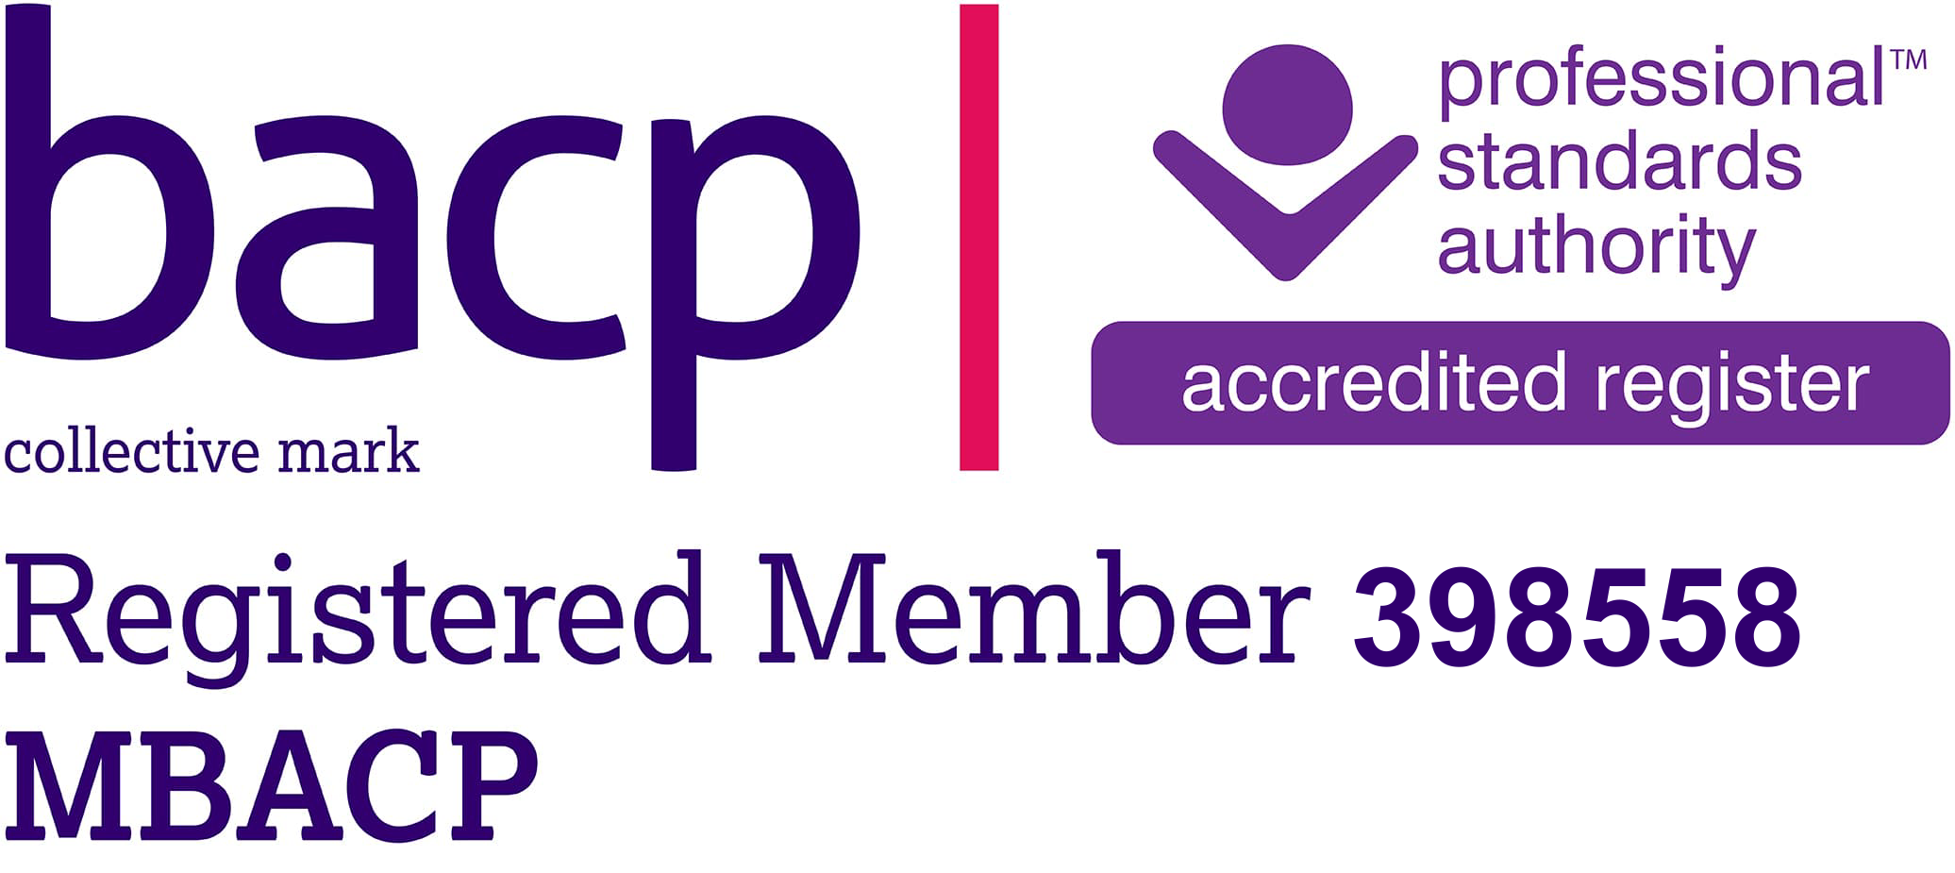

Counsellor Signature:
Helen Skene

